***Problem Statement:***

* In present scenario, traditional ATM system accepts only on the PIN CODE security system, enabling the other person rather than the owner to access the account very easily.
* This ensures that the traditional ATM system is not fully secured.

***Objective:***

* The objective of our project is to provide biometric security through fingerprint authentication in ATM application.
* The underlying principal is the phenomenon of biometrics “AUTHENTICATION”, in this project we propose a method for fingerprint matching based on matching algorithms.

***Introduction:***

* Fingerprint is the person’s most unique physical characteristics.
* This Software can pick only authentic fingerprint out of crowd, extract that fingerprint is compared from rest of which those are stored in database
* The fingerprint authentication problem can be grouped into two sub-domains i.e. Fingerprint Verification and Fingerprint identification.

***Scope:***

* The ATM system is designed to run for 24 hours and to allow bank clients to carry out transactions in a secured way. The data will be held in a bank database. The system is connected to the bank database using a modem.

***Description and Methodology:***

* To use the fingerprint-based ATM system, users have to log in to their account using their fingerprint.
* The user gets three chances to get him authenticated. If the fingerprints do not match, further authentication will be needed.
* After logging in, once they provide their unique pin, they can conduct all kinds of banking transactions, from withdrawing cash to money transfer, and even viewing their account balance.
* Furthermore, users can also check the last five transactions from their account.

***Resource Requirements:***

***Software Requirements:***

Windows 7 and above

Microsoft SQL Server

Visual Studio

***Hardware Components:***

Processor – i3

Hard Disk – 5 GB

Memory – 1GB RAM

***Advantages:***

1. Very high accuracy and security

*Identification* (Do I know who you are?)

*Verification* (Are you who you claim to be?)

1. It is one of the most developed biometrics.
2. User can make transactions using his fingerprint anywhere and at any time, he need not have to carry ATM card.
3. Small storage space required for the biometric template, reducing the size of the database memory required.
4. Enhance traditional methods (PINs, Passwords).

***Disadvantages:***

1. ***Misidentification***

False Acceptance

False Rejection

1. ***Damaged Finger Pattern***

If the user finger pattern has some cut or got damaged, the system might not recognize the user.

***Conclusion:***

* This project is a desktop application that uses the fingerprint of users for authentication.
* Since each individual has a unique fingerprint, this method of using fingerprint as a means of authentication to access your ATM is safer and more secure than using an ATM card.

***Use Cases:***

1. Log-in
2. Sign-up
3. Deposit
4. Withdraw
5. Transfer
6. Monthly Transactions
7. Log-out

**_______________________________**

***Use Case Diagram***

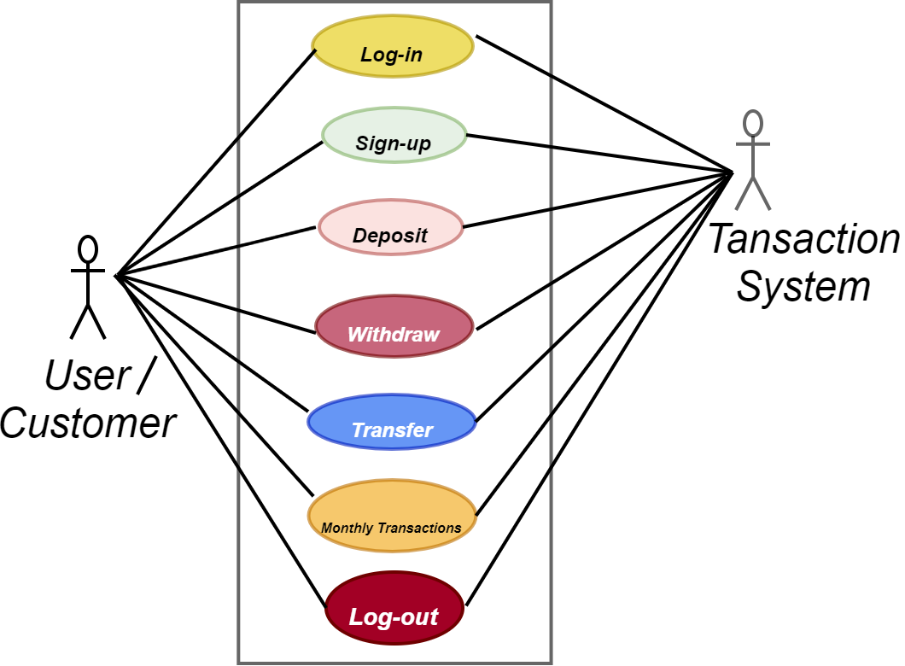

***Use Case:*** Log-in

***Primary Actor:*** User

***Goal in Context:*** The user will authenticate and make transaction using biometric fingerprint.

***Preconditions:*** Customer must provide with a valid Fingerprint or Card to Log-in

***Trigger:*** When customer place finger on the Screen

***Scenario:***

User: Place the Finger

User: Enter pin

ATM System: Authenticate the Customer

User: Check Balance

User: Make Transactions

User: Generate Slip

***Priority:*** Customer must have an account stored in the database of Bank ATM System.

***When available:*** As ATM is open all the time, so customer can log-in at anytime

***Frequency of use:*** Multiple times as long as the customer have active ATM account.

***Secondary Actors:*** Transaction System of Bank ATM

***Channel to use:*** By Bank ATM

***Channels to Secondary actors:*** Verify Customer by making access through database in Bank ATM System

***Open Issues:***

What if ATM interprets the correct Fingerprint as False input or vice versa?

What if the customer has cut at his/her fingerprints or something else?

***Log-in Activity Diagram***

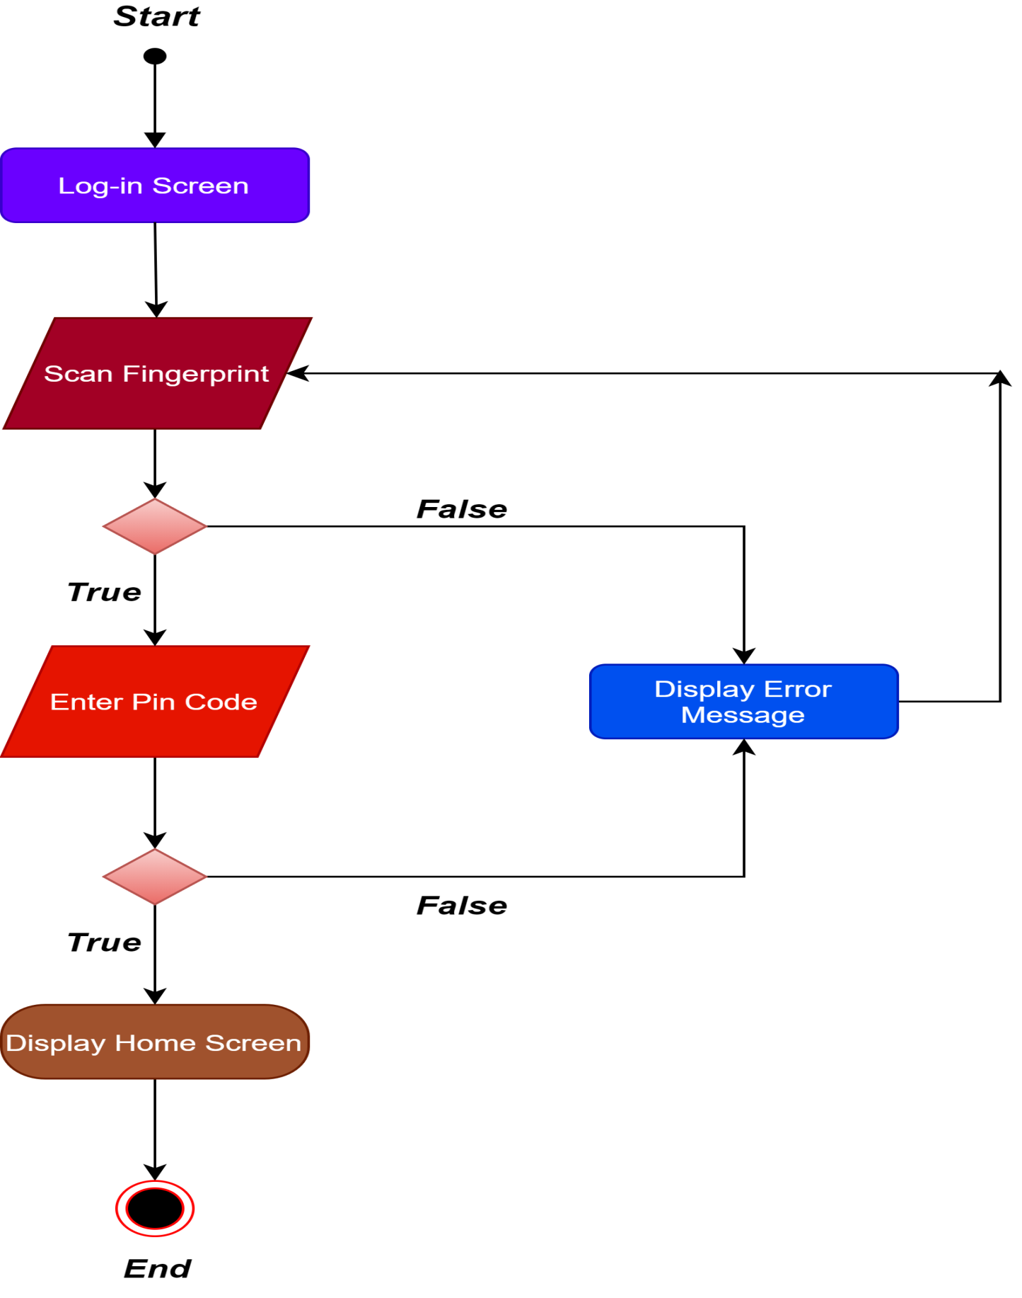

***Swimlane Diagram***

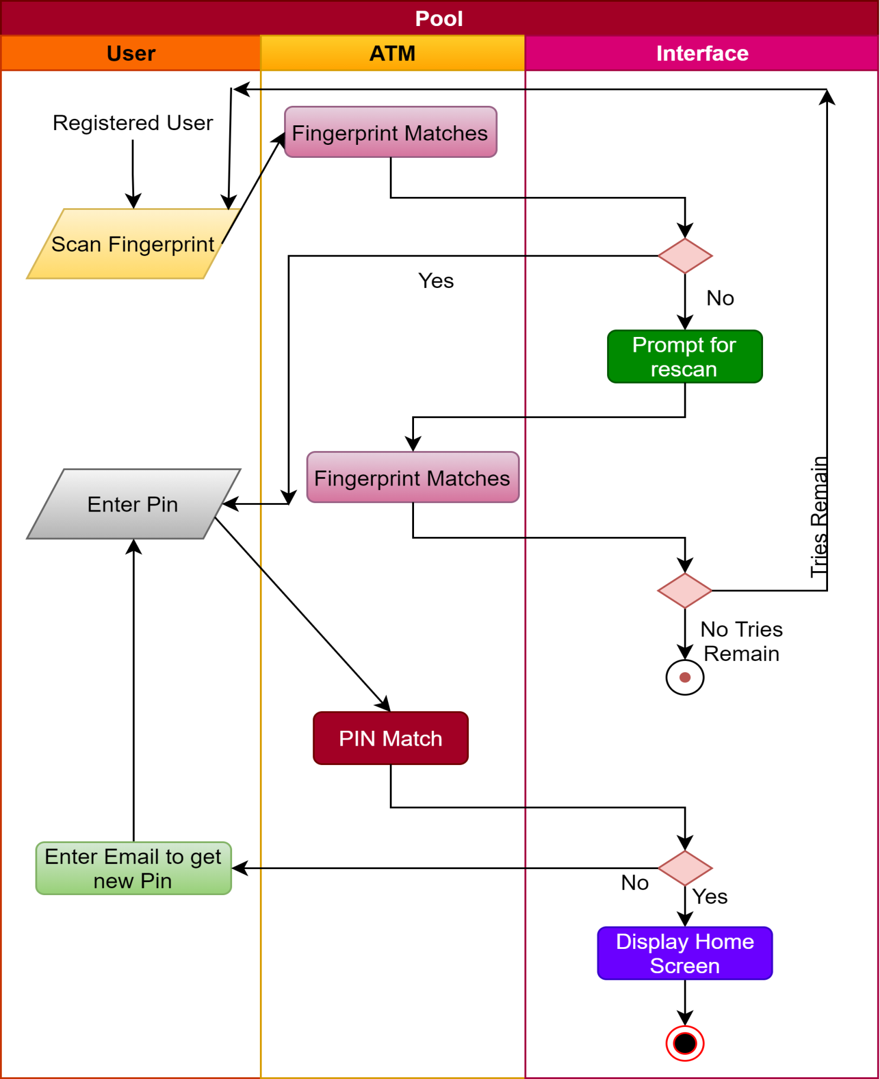

***Use Case:*** Sign Up

***Primary Actor:*** Customer

***Goal in Context:*** The web portal for fingerprint-based ATM system requires a sign-up process to register an account into the system database. Once the user is registered into the system, he/she can access all the features of the application.

***Preconditions:*** The user has to add their email address, name, basic information and fingerprint. To activate his/her account the verification of his fingerprint and correct email is required.

***Trigger:*** When customer choose sign up to register himself

***Scenario:***

Customer: Place the Finger

Customer: Enter Email

ATM System: Authenticate the Customer

Customer: Get Pin through Email

***Priority:*** Customer must have to enroll himself to access the features.

***When available:*** As ATM is open all the time, so customer can Sign-up at anytime

***Frequency of use:*** Customer has to register himself just for once

***Secondary Actors:*** Transaction System of Bank ATM

***Channel to use:*** By Bank ATM

***Channels to Secondary actors:*** Stored the information of customer in Bank Database System.

***Open Issues:***

What if ATM interprets the correct Fingerprint as False input or vice versa?

What if the customer has cut at his/her fingerprints or something else?

Can someone access to ATM by hacking customer Email?

***Sign Up Activity Diagram***

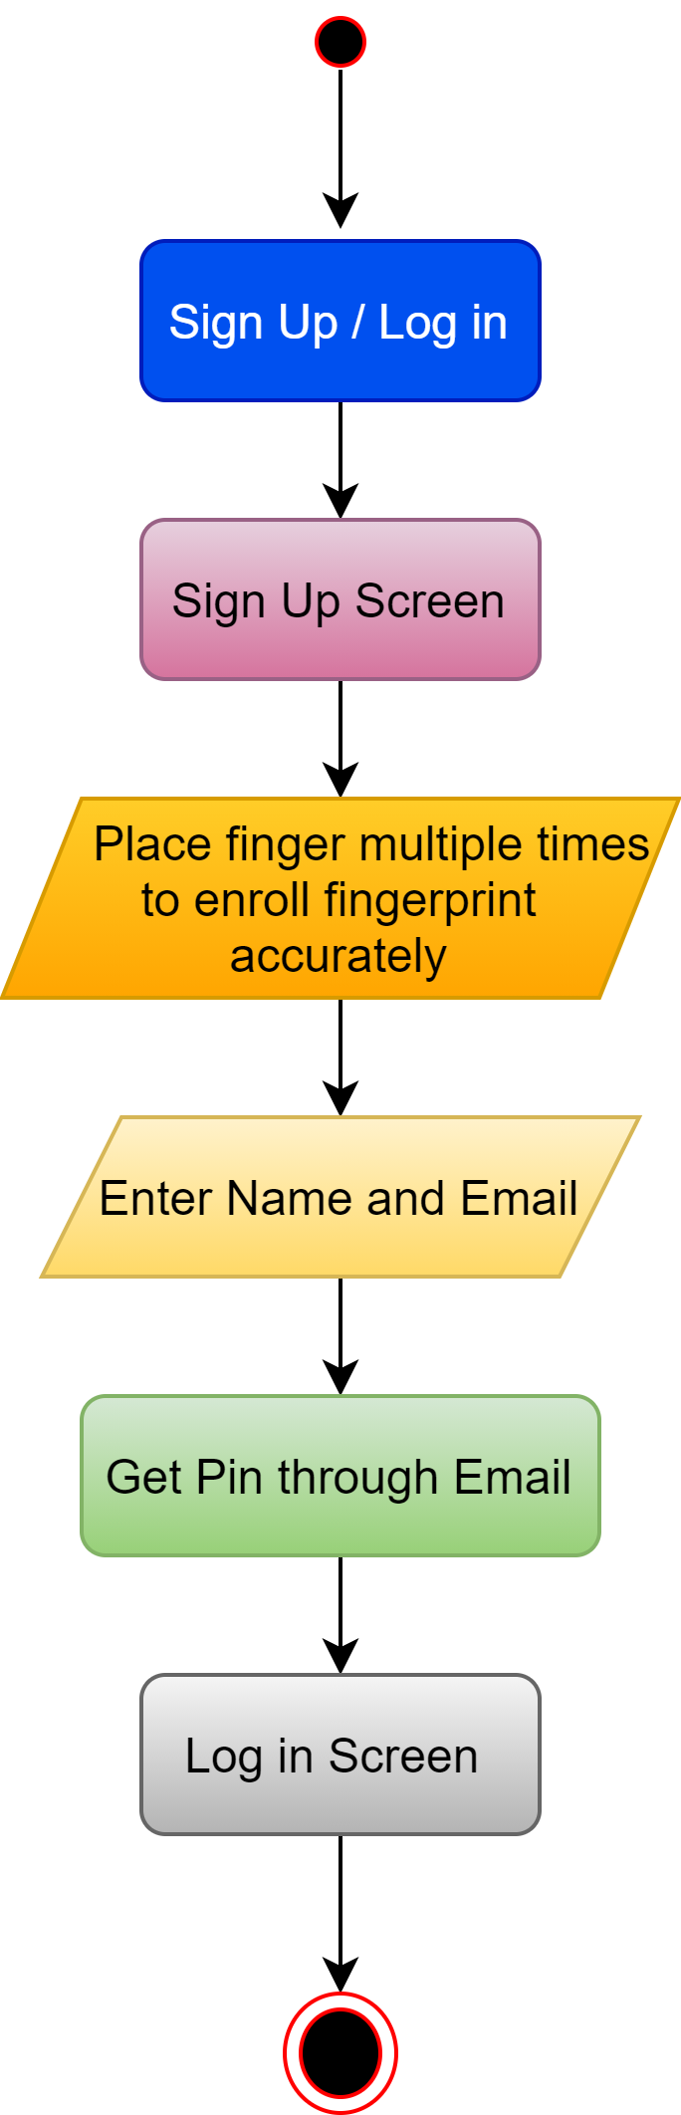

***Swimlane Diagram***

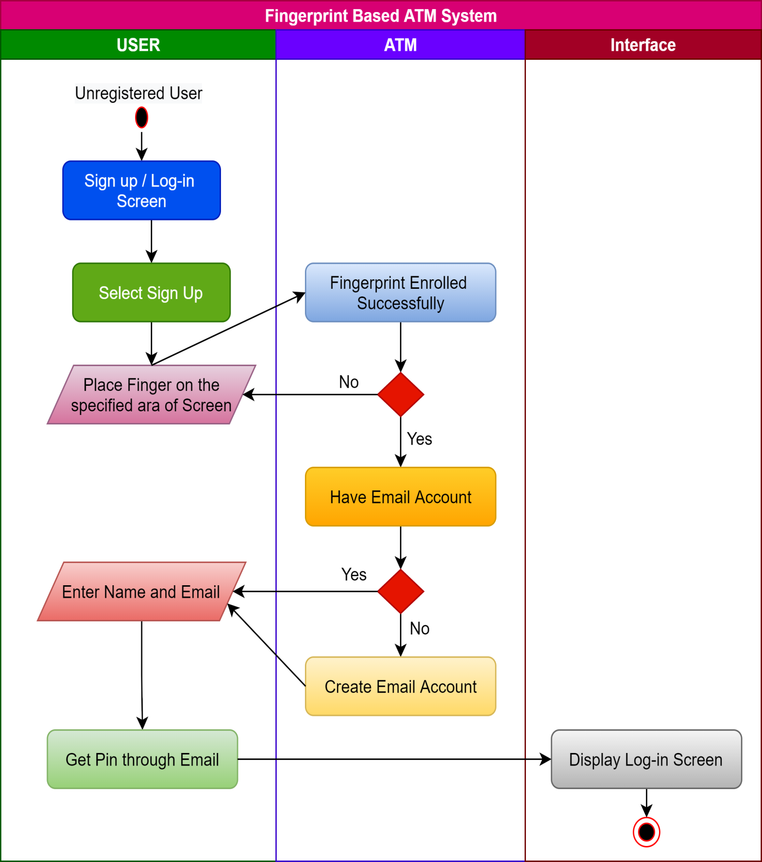

***Use Case:*** Deposit

***Primary Actor:*** User

***Goal in Context:*** The User will Log-in and Deposit the Amount.

***Preconditions:*** The requirements for a successful deposit are that the user must successfully be logged into the system and he/she should not enter a negative amount that isn’t defined in system parameters.

***Trigger:*** When User Log-in and select to deposit the money.

***Scenario:***

User: Place the Finger

User: Enter Pin

ATM System: Authenticate the Customer

User: Deposit Selection via cash or cheque.

ATM System: Validate Entered item and update the account.

***Priority:*** User has to deposit money into his account.

***When available:*** As ATM is open all the time, so customer can deposit money at anytime

***Frequency of use:*** Multiple times.

***Secondary Actors:*** Transaction System of Bank ATM

***Channel to use:*** By Bank ATM

***Channels to Secondary actors:*** First verify the user through Bank database and then update his account after user deposit the money.

***Open Issues:***

What if ATM interprets the correct Fingerprint as False input or vice versa?

What if the user doesn’t get verification Email of successful money deposit?

***Deposit Activity Diagram***

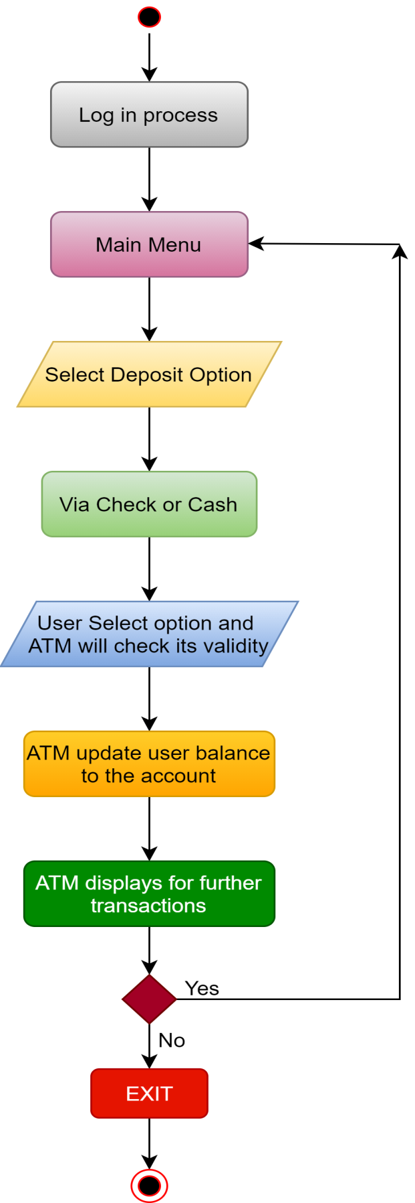

***Swimlane Diagram***

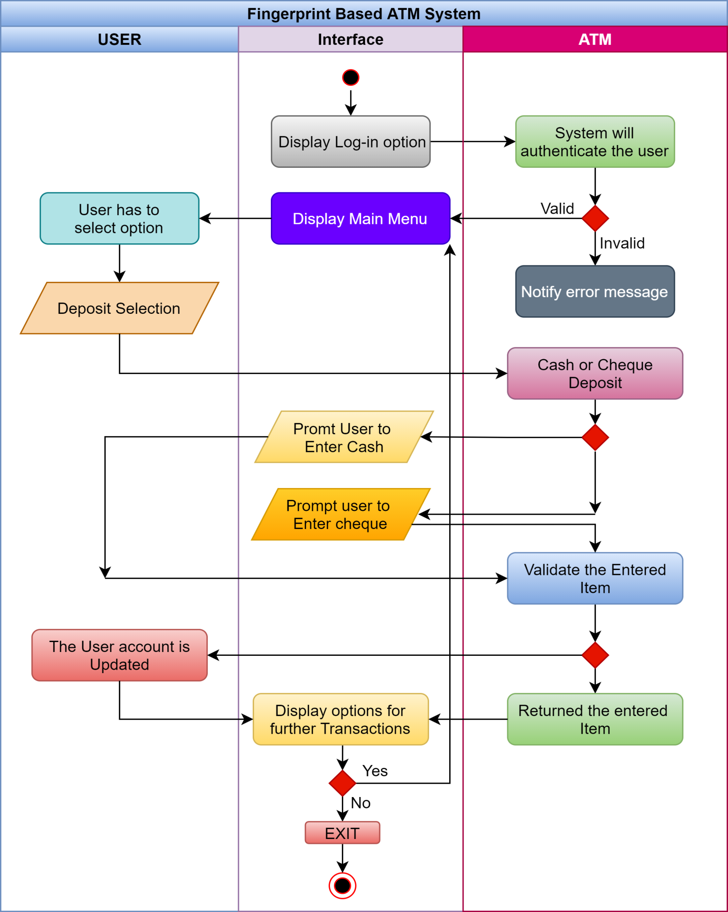

***Use Case:*** Cash Withdraw

***Primary Actor:*** User

***Goal in Context:*** The User will Log-in and Withdraw money from his account.

***Preconditions:*** User must be sign-in and has enough amounts in his account.

***Trigger:*** When User Log-in and select to Withdraw the money.

***Scenario:***

User: Place the Finger

User: Enter Pin

ATM System: Authenticate the Customer

User: Withdraw money Selection

ATM System: Check for required money is present or not then update user’s account.

***Priority:*** User has to withdraw money into his account.

***When available:*** As ATM is open all the time, so customer can withdraw money at anytime

***Frequency of use:*** Multiple times as long as user’s account has enough amount to withdraw.

***Secondary Actors:*** Transaction System of Bank ATM

***Channel to use:*** By Bank ATM

***Channels to Secondary actors:*** First verify the user through Bank database and then update his account after user withdraws the money.

***Open Issues:***

What if ATM interprets the correct Fingerprint as False input or vice versa?

What if the user doesn’t get verification Email of successful money withdraw?

***Cash Withdraw Activity Diagram***

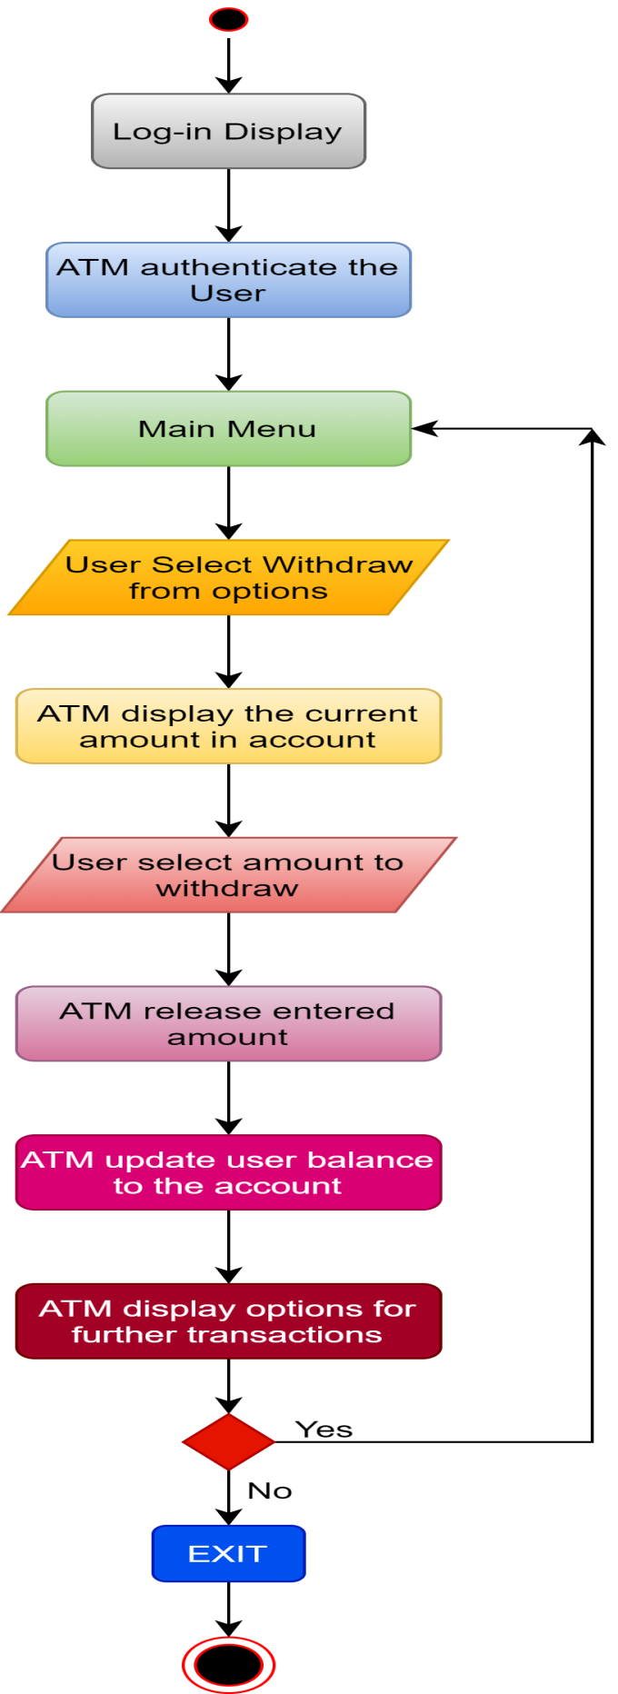

***Swimlane Diagram***

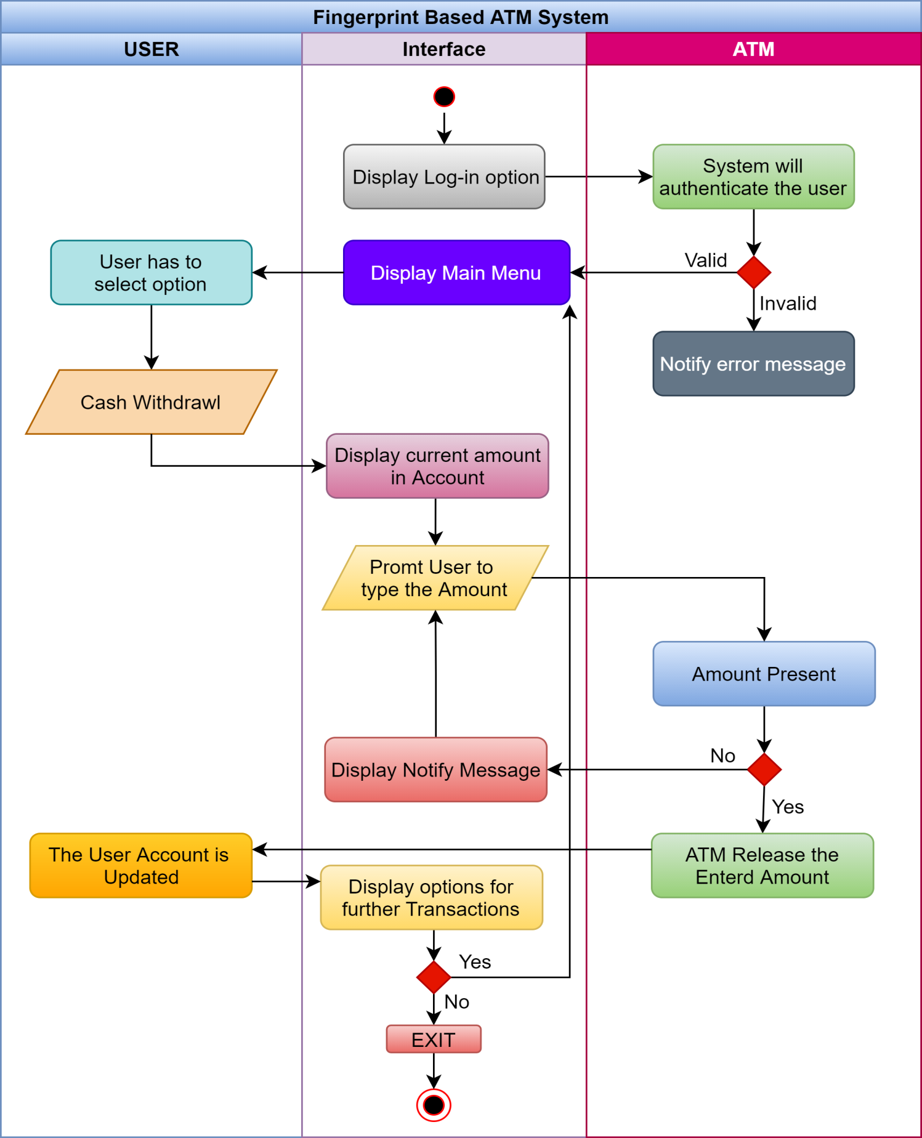

***Use Case:*** Money Transfer

***Primary Actor:*** User

***Goal in Context:*** The User will Log-in and Transfer money from his account to another.

***Preconditions:*** User must be sign-in and has enough amounts in his account to transfer.

***Trigger:*** When User Log-in and select to Transfer the money.

***Scenario:***

User: Place the Finger

User: Enter Pin

ATM System: Authenticate the Customer

User: Transfer money Selection

ATM System: Verify receiver’s account number and whether is there enough money to transfer or not and then transfer the money. Later, the user account will update.

User: Will get notification of successful transfer through Email.

***Priority:*** User has to transfer money from his account.

***When available:*** As ATM is open all the time, so customer can transfer money at anytime

***Frequency of use:*** Multiple times as long as user’s account has enough amount to transfer.

***Secondary Actors:*** Transaction System of Bank ATM

***Channel to use:*** By Bank ATM

***Channels to Secondary actors:*** First verify the user through Bank database and then update his account after user transfers the money.

***Open Issues:***

What if ATM interprets the correct Fingerprint as False input or vice versa?

What if the user doesn’t get verification Email of successful money transfer?

***Money Transfer Activity Diagram***

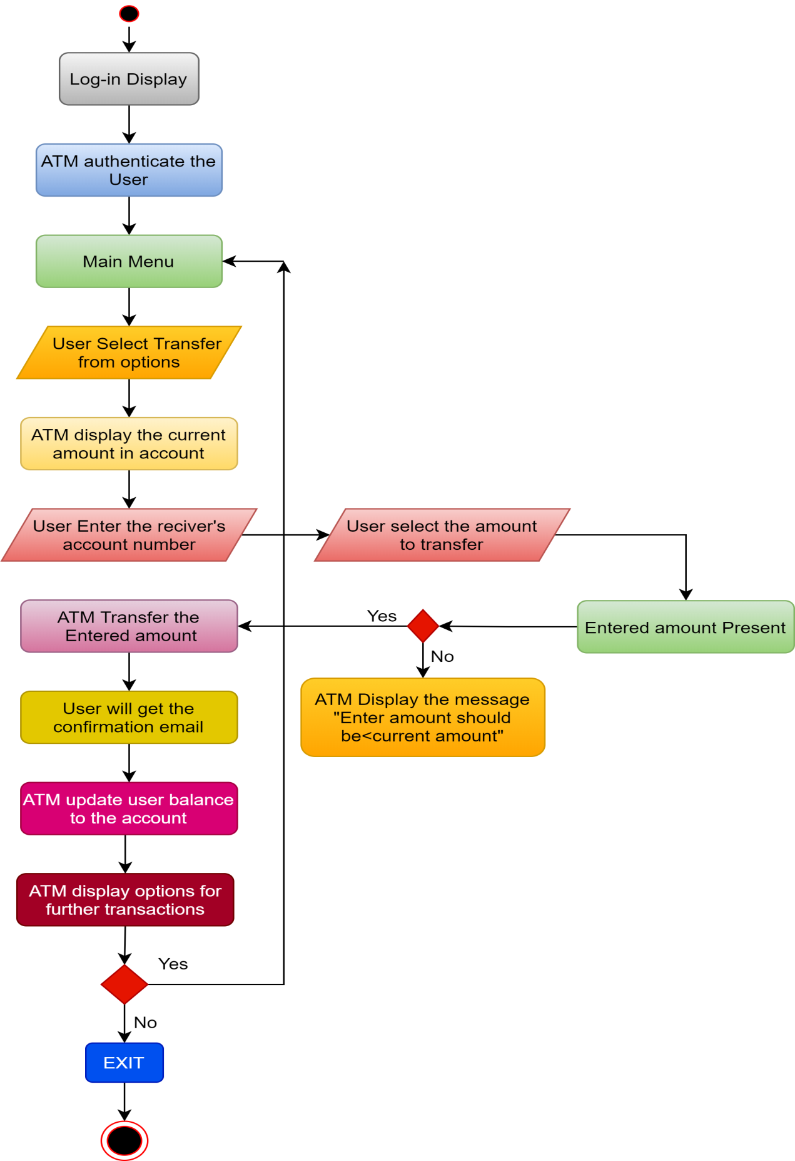

***Swimlane Diagram***

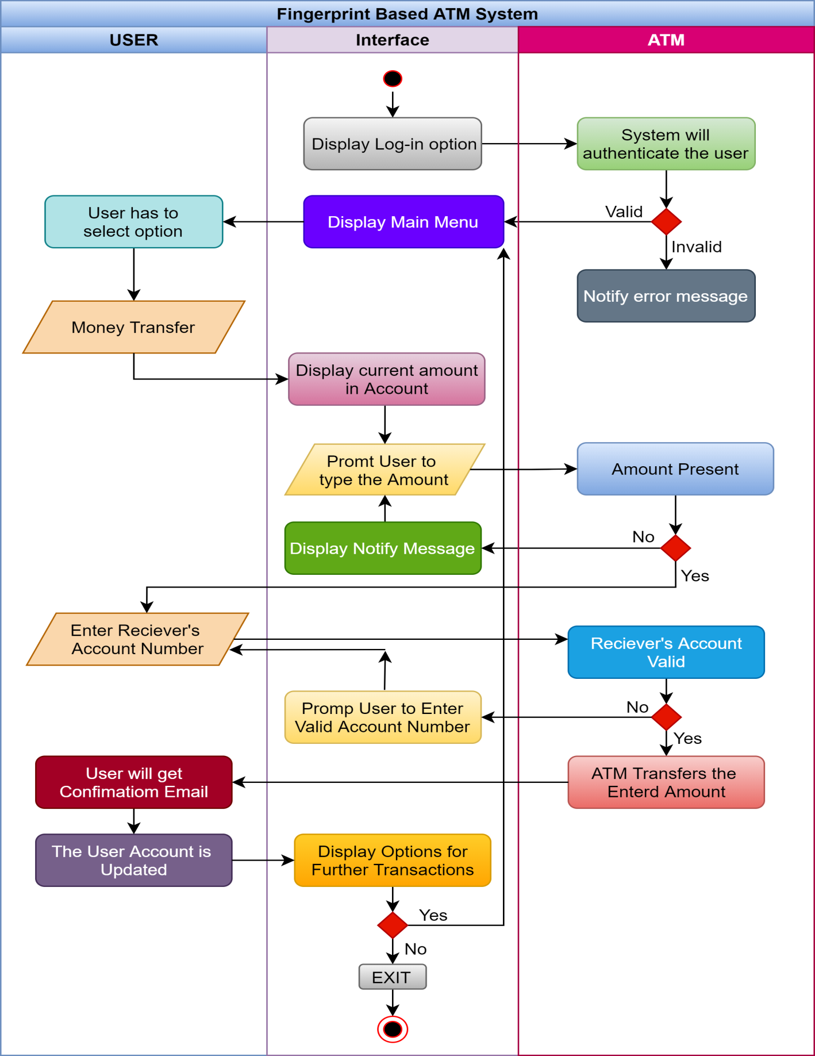

***Use Case:*** Monthly Transactions

***Primary Actor:*** User

***Goal in Context:*** The User will Log-in and view his monthly transactions history.

***Preconditions:*** User must be sign-in successfully.

***Trigger:*** When User Log-in and select to view monthly transactions.

***Scenario:***

User: Place the Finger

User: Enter Pin

ATM System: Authenticate the Customer

User: View Transaction History

***Priority:*** User has to view his account’s transactions history

***When available:*** As ATM is open all the time, so customer can view his account history at anytime

***Frequency of use:*** Multiple times whenever user wants to.

***Secondary Actors:*** Transaction System of Bank ATM

***Channel to use:*** By Bank ATM

***Channels to Secondary actors:*** First verify the user through Bank database and then display the user’s account history

***Open Issues:***

What if ATM interprets the correct Fingerprint as False input or vice versa?

What if the ATM does not display the correct history?

Can it be changed or hacked by someone else?

***Monthly Transactions Activity Diagram***

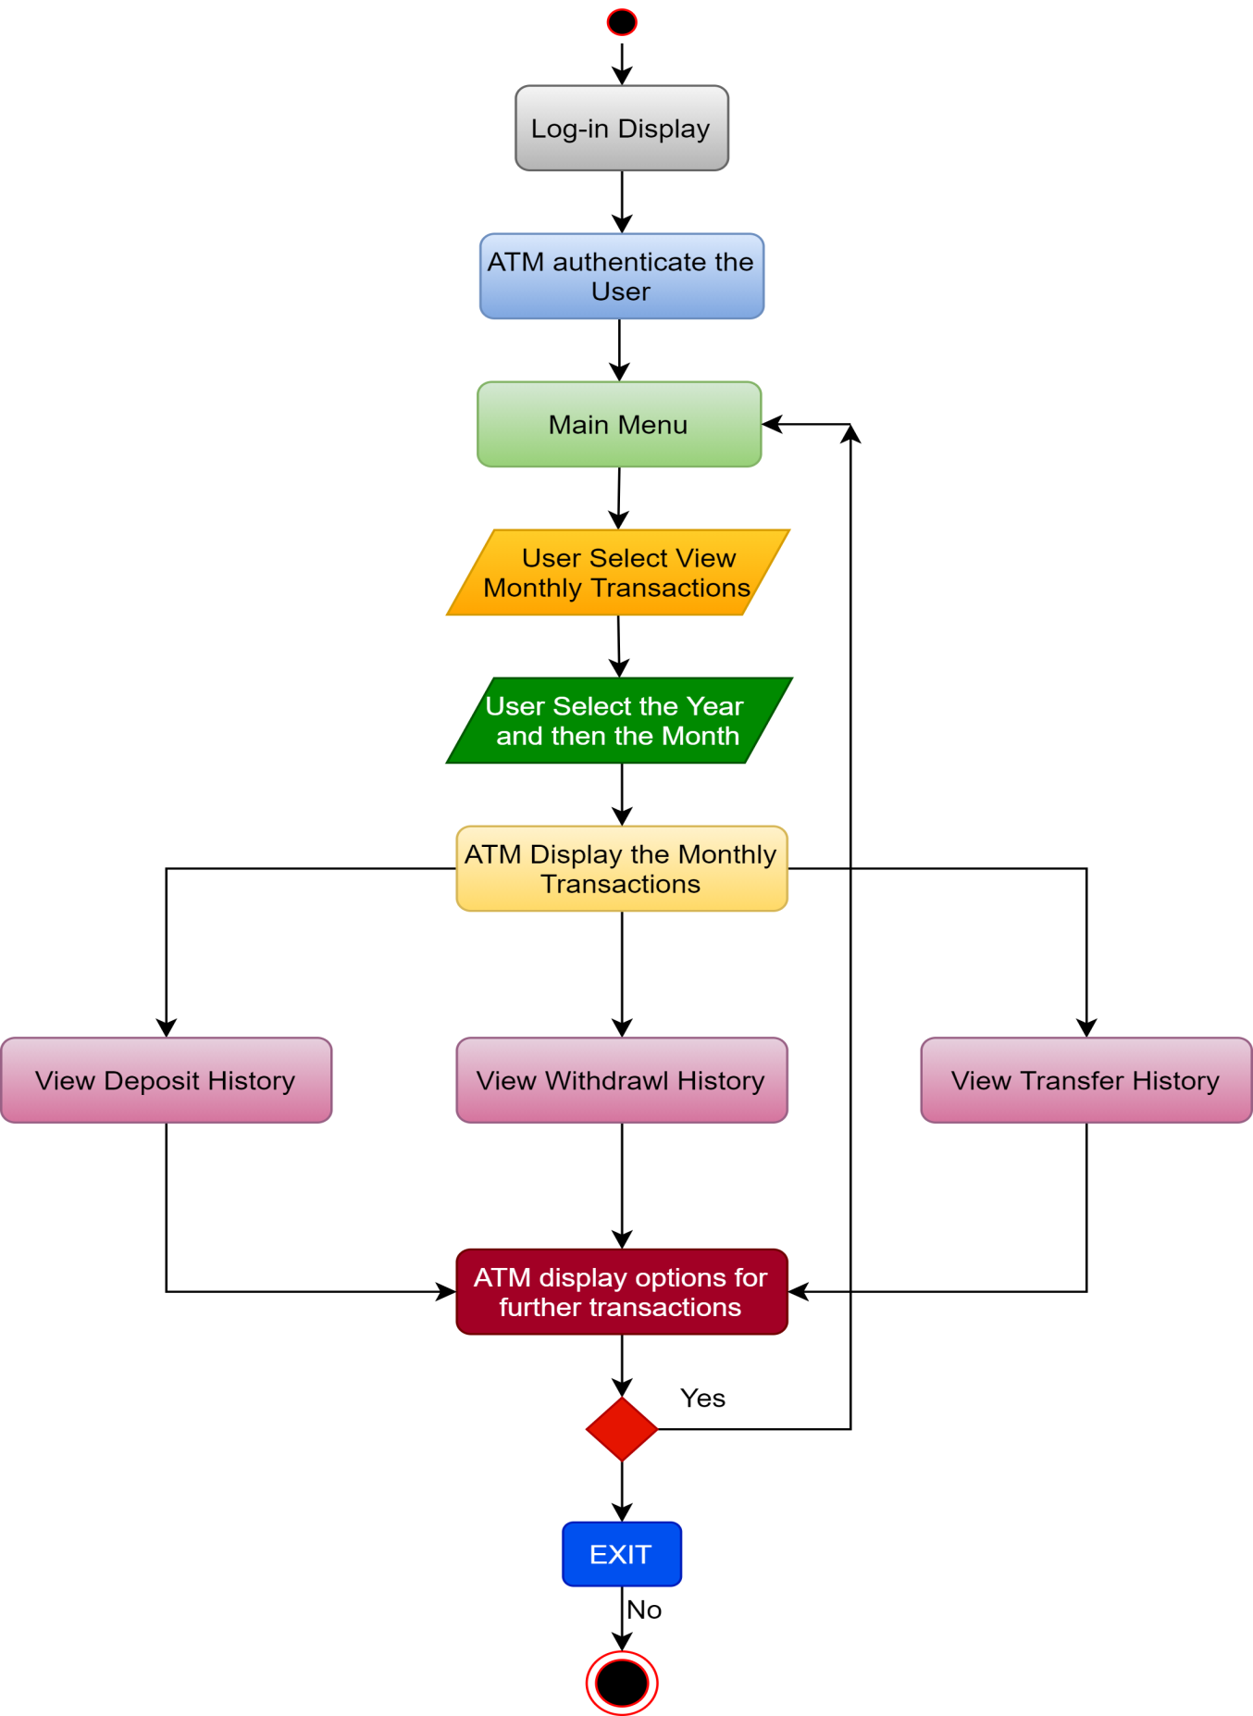

***Swimlane Diagram***

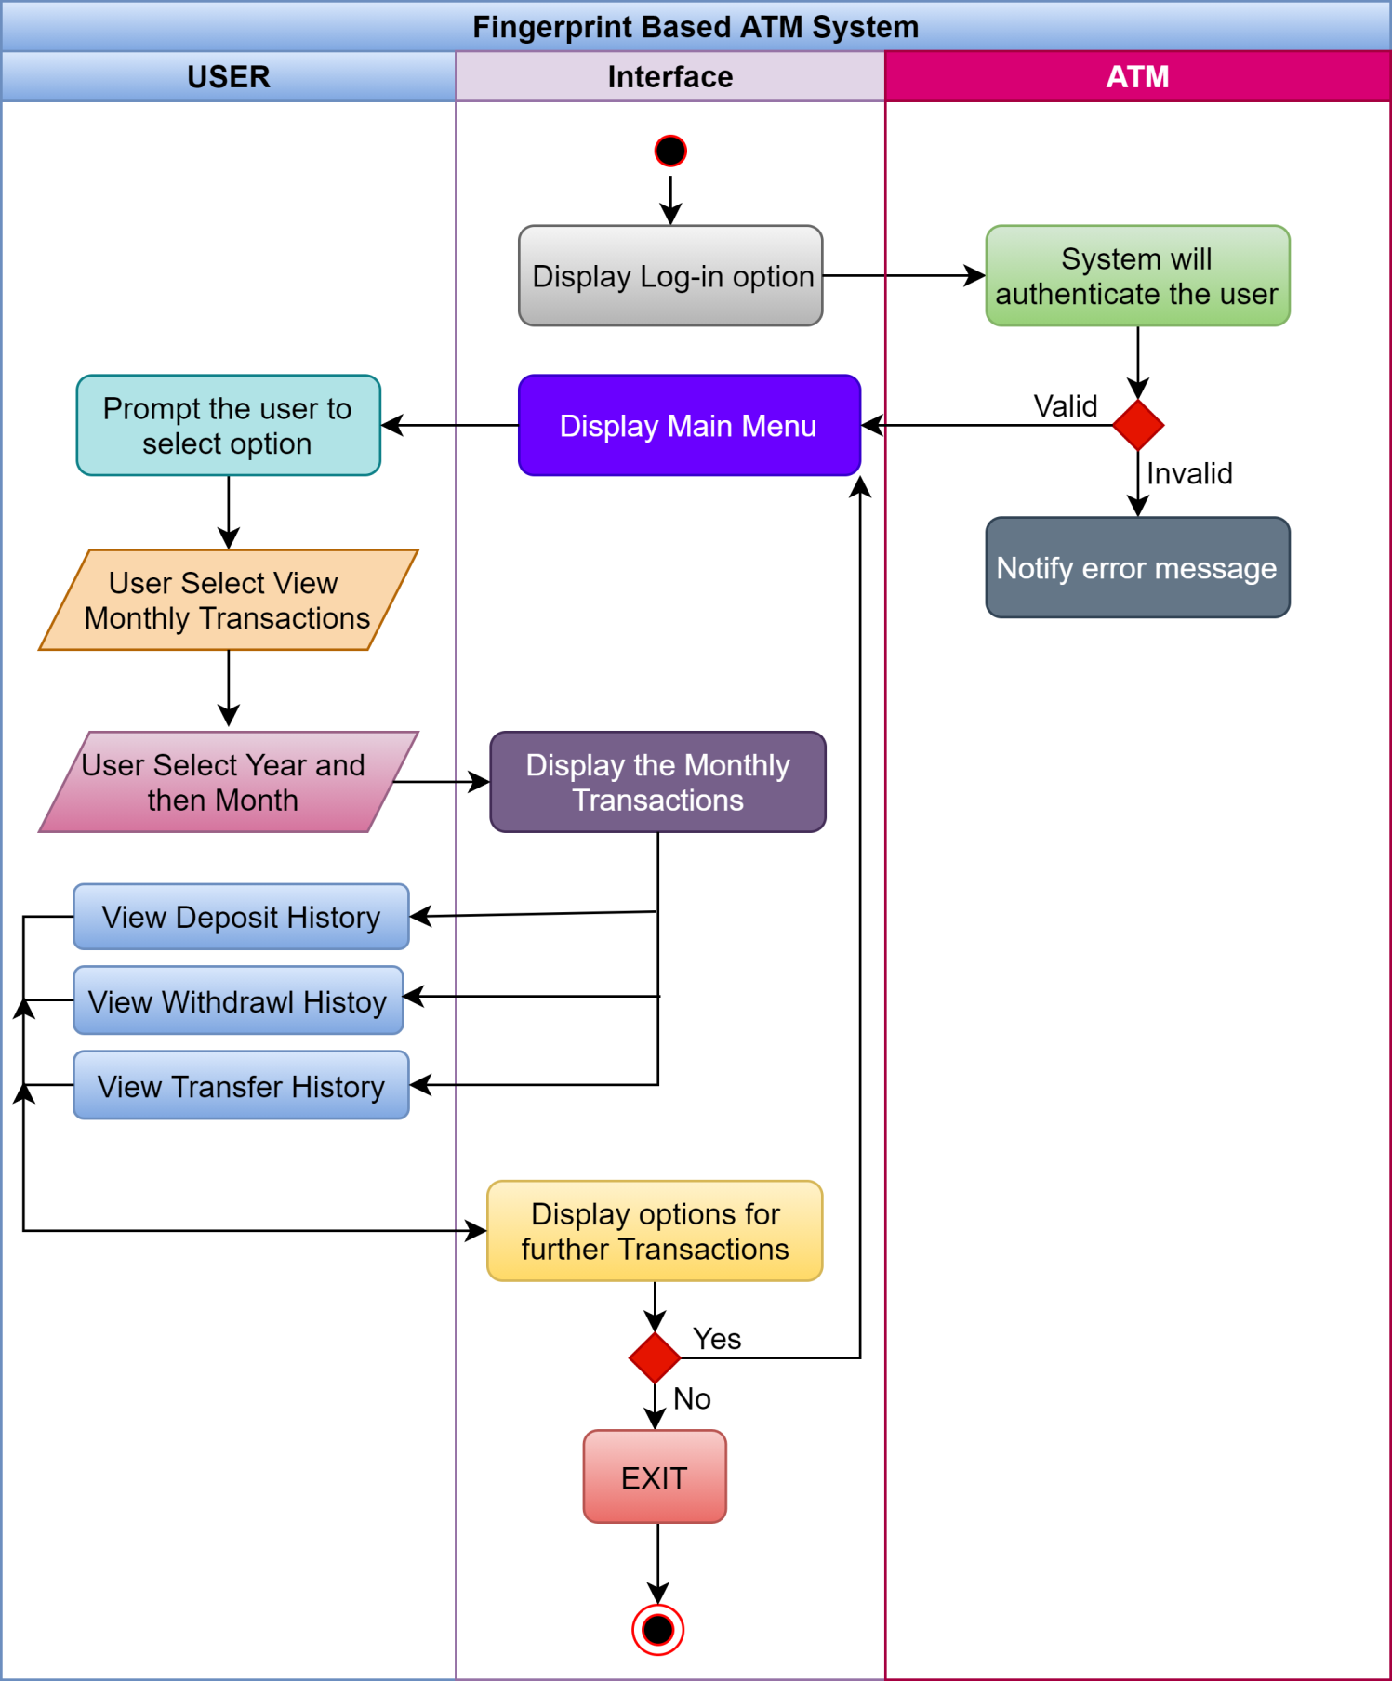

***Use Case:*** Log-out

***Primary Actor:*** User

***Goal in Context:*** The User will Log-in and after performing the willful task he will log-out.

***Preconditions:*** User must be sign-in successfully.

***Trigger:*** When User Log-in and select to log-out after performing some task.

***Scenario:***

Customer: Place the Finger

User: Enter Pin

ATM System: Authenticate the Customer

User: Choose to log-out

***Priority:*** User has to log-out from his account

***When available:*** As ATM is open all the time, so customer can access it and log-out at any time.

***Frequency of use:*** Multiple times whenever user wants to.

***Secondary Actors:*** Transaction System of Bank ATM

***Channel to use:*** By Bank ATM

***Channels to Secondary actors:*** First verify the user through Bank database and then display home screen after user logs out.

***Open Issues:***

What if ATM interprets the correct Fingerprint as False input or vice versa?

**______________________________________**

***Sign out Activity Diagram***

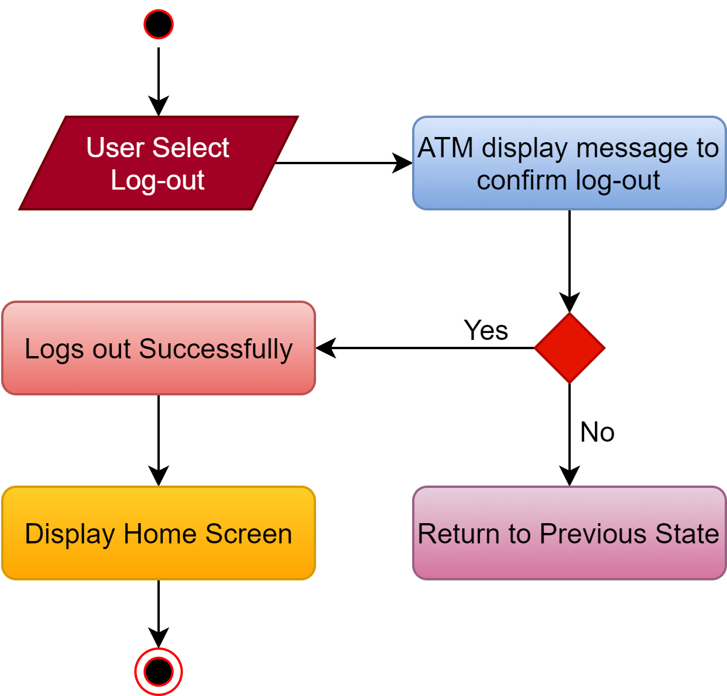

***Swimlane Diagram***

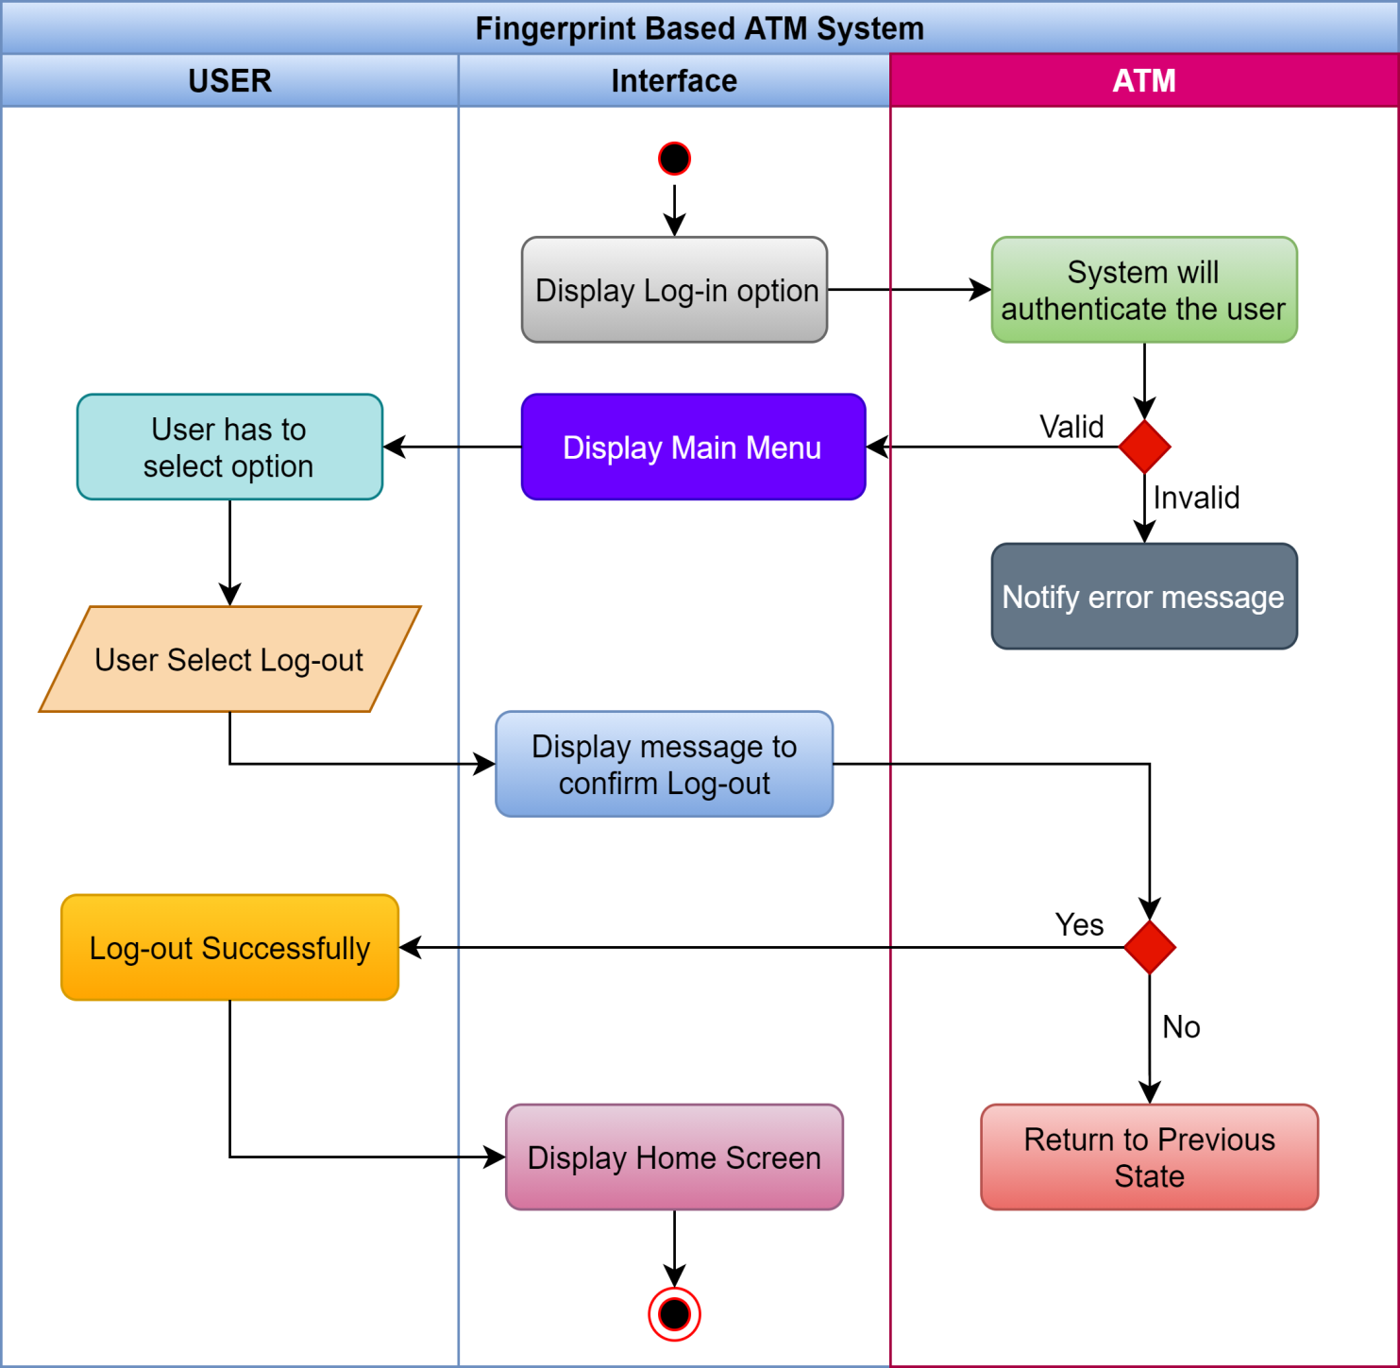

**__________________________**

***Sequence Diagram 1***

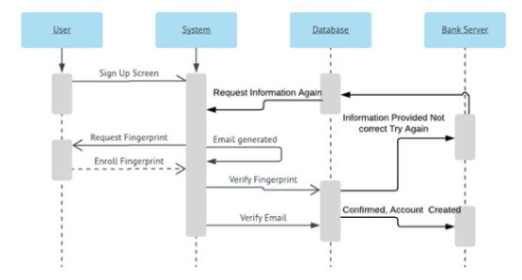

***Sequence Diagram 2***

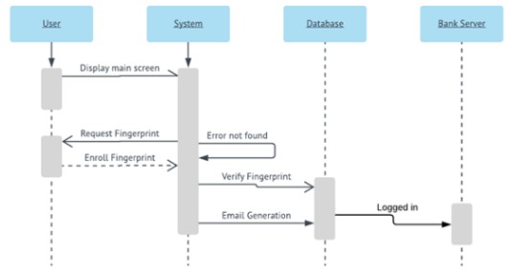

***Sequence Diagram 3***

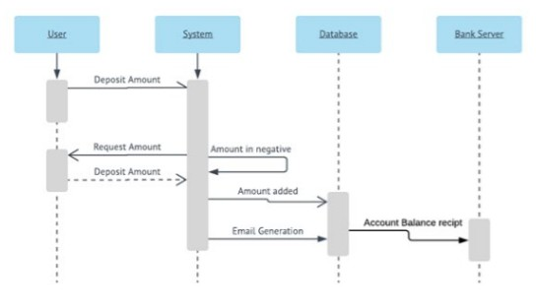

***Sequence Diagram 4***

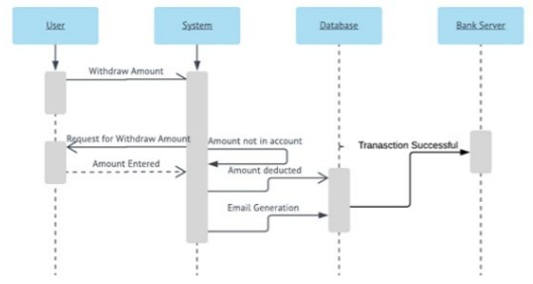

***Sequence Diagram 5***

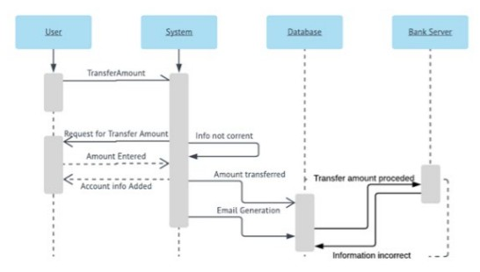

***State Diagram***

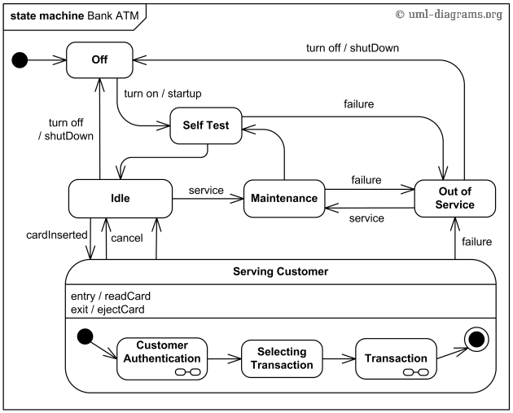

***Class Diagram***

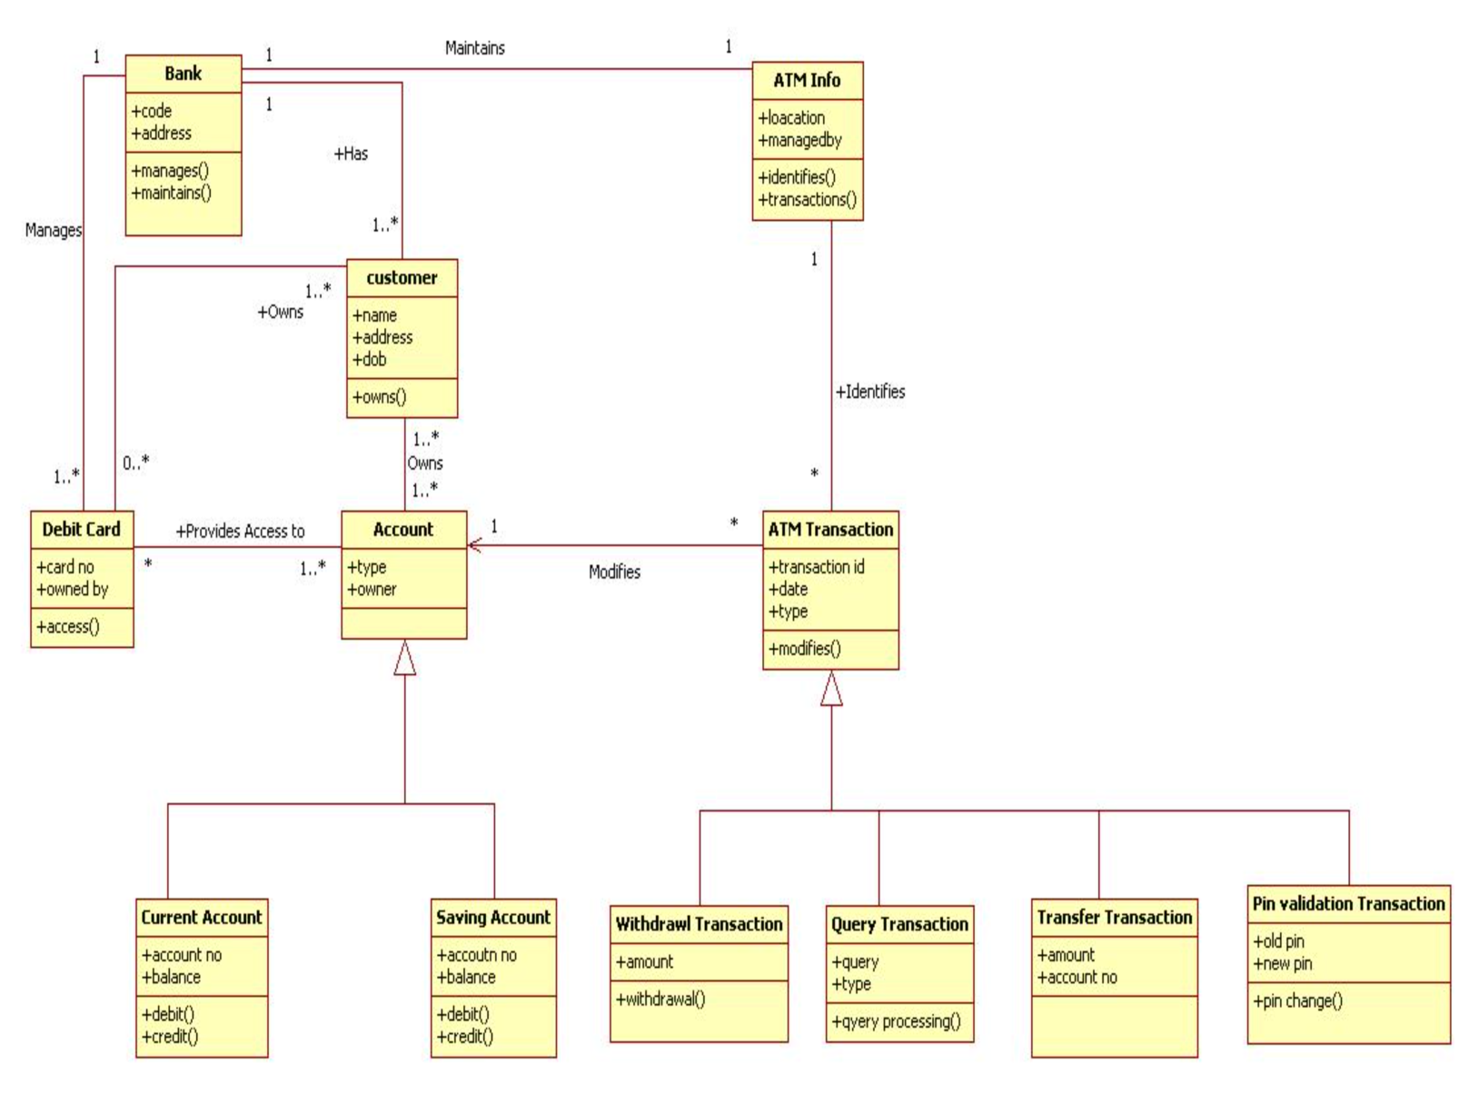

***CRC CARDS***

**Basic user stories:**

1. User checks balance
2. User logs into the machine
3. User get "Fast Cash"
4. User makes a deposit
5. User withdraws from checking
6. User withdraws from savings
7. Transfer Money
8. View Balance

|  |  |
| --- | --- |
| **User Menu**  **Responsibilities Collaborators** | |
| Scan Fingerprint  Display main menu Ask user for PIN  Send PIN to Bank System for validation Display validation errors  Ask Bank System for balance Print Balance  Display Fast Cash menu Debit Account  Dispense Money Print Receipt  Transfer Money  View Balance | Fingerprint Scanner  Bank System  Bank System  Printer  Bank System Money Dispenser Printer  Bank System |

|  |  |
| --- | --- |
| **Bank System**  **Responsibilities Collaborators** | |
| Validate PIN  Get Balance | Bank Database |

|  |  |
| --- | --- |
| **Card Reader**  **Responsibilities Collaborators** | |
| Detect card inserted  Tell User Menu to ask for PIN | User Menu |

|  |  |
| --- | --- |
| **Printer**  **Responsibilities Collaborators** | |
| Print Balance Print Receipt |  |

|  |  |
| --- | --- |
| **Money Dispenser**  **Responsibilities Collaborators** | |
| Dispense Money |  |

**_________________________________________________**